The University of Alabama in Huntsville
Office of Sponsored Programs

Quick Desk Guide: Budget Changes

Budget changes are used for: Budget changes cannot be
used for:
- Crediting new award funds to an account X Moving funds between accounts under
- Deobligating (removing) new award funds different contracts (see cost transfers)
from an account X Moving charges between accounts (see
- Moving funds between subcodes within an cost transfers)
account
- Moving funds between accounts (ONLY
IF THE ACCOUNTS ARE UNDER THE
SAME CONTRACT.)

Points to remember:
- If moving funds between subcodes, transactions must balance (your decreases must equal your increases)
- All non-student salary is proposed and credited with 25% fringe benefits so salary funds transactions must always include the 25% fringe benefits
- Graduate Research Assistants (GRA) always have tuition (fringe benefit attached to their salary and it must be considered in the same way as the 25% fringe benefits when moving funds
- Almost all funds (subcontract amounts over the first $25K and equipment are the most common exceptions) have facilities & administrative costs (indirect) attached. This is usually 45.5% or 26% of any expenditure (For every salary/fringe benefit $, you must also consider 45.5% or 26% F&A)
- The budget unit head (usually PI) must sign this document. Budget changes involving “5” or “2-70xxx” accounts must ALWAYS be signed by the Office of Sponsored Programs.

Parts of a “Request for Budget Change” form:
- Budget Change Number: this is assigned by Contract & Grant Accounting after the form has been submitted and is used for tracking;
- Date: Date of transaction origination;
- Division/School & Department: The unit fiscally
responsible for the account;
- I(ncrease)/D(ecrease): Transaction instruction to
Contract & Grant Accounting;
- Account Number: 5-xxxxx or 2-70xxxx;
- Account code: See account code list at www.uah.edu/admin/Finance/crosswalks.html. Note: the “6500 (employee benefits) or “7000” (operating costs) do not require transactions at the subcode level;
- Description: Account code name (see account code list at www.uah.edu/admin/Finance/crosswalks);
- Amount to increase or decrease by account code;
- Description of the transaction: This is an official record of the transaction. Provide sufficient information to facilitate future inquiries.
- Signatures: Must have the budget unit head (or someone with signature authority) and a Office of Sponsored Programs’ representative.

Sample Budget Changes

Sample budget change 1: “PI wants to move $5,000 from operating account code to salaries to support a Research Associate”

Decrease account code “7000” in the amount of $5,000;
Divide $5,000 by 1.30 to determine amount to increase account code “6150” (Professional nonfaculty).
Increase account code “6150” by $4,000 and increase account code “6500” by $1,000. (Fringe benefits are 30% of salary amount.)

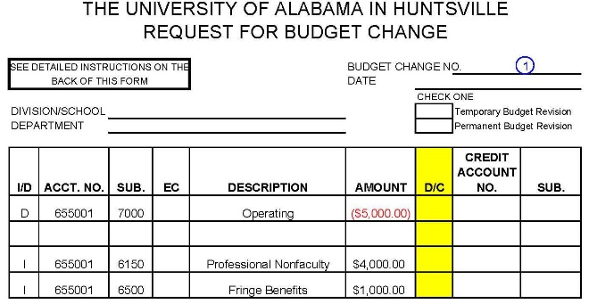

Sample budget change 2: “PI wants to move $5,000 from salaries to operating to purchase supplies”

Divide $5,000 by 1.30 to determine amount to decrease the salary subcode;
Decrease account code “6150” in the amount of $4,000;
Decrease accountcode “6500” in the amount of $1,000;
Increase account code “7000” in the amount of $5,000.

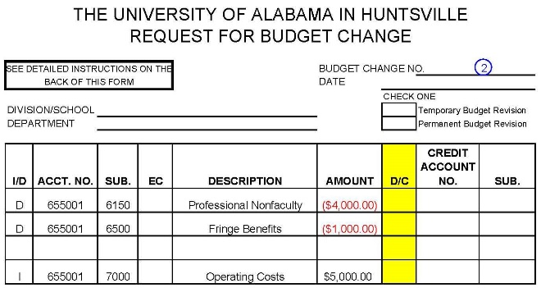

Sample budget change 3: “PI wants to move $10,000 from equipment (“8100”) account code to operating (“7000”) account code” (this is an account with 46.5% F&A)

Divide $10,000 by 1.465 to determine the amount of funds that can be moved to account code “7000”;
Decrease account code “8100” by $10,000;
Increase account code “7000” by $6,872.85;
Increase account code “7900” by $3,127.15.

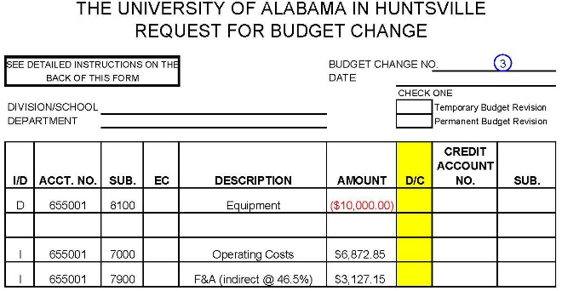

Sample budget change 4: “PI wants to move $10,000 from operating (“7000”) account code to equipment “8100”) account code” (this is an account with 46.5% F&A)

Divide $10,000 by 46.5%;
Decrease account code “7000” by $6,872.85;
Decrease account code “7900” by $3,127.15;
Increase account code “8100” by $10,000.

